# DESIGN AND IMPLEMENTATION OF WEB APPLICATION ON LEARNING STOCK MARKET EXCHANGE

*This project report is submitted to*

*Rashtrasant Tukadoji Maharaj Nagpur University*

*in the partial fulfilment of the requirement for the award of the degree of*

## Bachelor of Technology in Computer Technology

*By*

**Mr. Aditya Darne (CT20050)**

**Ms. Sakshi Poshattiwar (CT20092)**

**Ms. Vaishnavi Puttewar(CT20058)**

**Ms. Janhvee Barai (CT20068)**

**Ms. Sanskruti Yarwar (CT20038)**

*Under the guidance of*

## Ms. Anagha Darokar

Assistant Professor



### 2022-2023

**DEPARTMENT OF COMPUTER TECHNOLOGY**

**KAVIKULGURU INSTITUTE OF TECHNOLOGY AND SCIENCE**

**RAMTEK, NAGPUR, MAHARASHTRA, INDIA-441 106**

**KAVIKULGURU INSTITUTE OF TECHNOLOGY AND SCIENCE RAMTEK, NAGPUR, MAHARSHTRA, INDIA – 441 106**

**DEPARTMENT OF COMPUTER TECHNOLOGY**

**CERTIFICATE**

This is to certify that the project report entitled **‘Design and Implementation of Web- Application on Learning Stock Market Exchange’** carried out by Mr. Aditya Darne (CT20050), Ms. Sakshi Poshaittwar (CT20092), Ms.Vaishnavi Puttewar (CT20058), Ms.Janhvee Barai (CT20068) and Ms.Sanskruti Yarwar (CT20038) of the B.Tech third year of Computer Technology, during the academic year 2022-2023, in the partial fulfilment of the requirement for the award of the degree of **Bachelor of Technology (Computer Technology)** offered by the **Rashtrasant Tukadoji Maharaj Nagpur University,** Nagpur.

Ms. Anagha Darokar

### Guide

Dr. Vilas.P. Mahatme Dr. Avinash N.Shrikhande

### Head of the Department Principal

Date:

Place: Ramtek

# ACKNOWLEDGEMENT

We are grateful to our guide **Ms. Anagha Darokar** for her kind, disciplined, invaluable guidance which inspired us to solve all the difficulties that came across during completion of project.

We express our special thanks to **Dr. Vilas P. Mahatme,** Head of the Department, for his kind support, valuable suggestions and allowing us to use all facilities that are available in the Department during this project.

Our sincere thanks are due to **Dr. Avinash N. Shrikhande**, Principal, for extending all the possible help and allowing us to use all resources that are available in the Institute.

We are also thankful to our **Parent** and **Friends** for their valuable co-operation and standing with us in all difficult conditions.

Project mates

# ABSTRACT

The stock market learning web application is a platform designed to educate individuals about investing in the stock market. The web application provides users with access to a comprehensive range of educational resources, including articles, videos, and tutorials, to help them understand the various aspects of stock market investing.

The platform will include features such as stock market simulations, interactive charts, and data analysis tools, enabling users to gain practical experience in a simulated environment. The application will also provide users with personalized recommendations based on their investment goals and risk tolerance.

Users will be able to create personalized portfolios, track their investments, and receive notifications about market trends and news. The web application will also provide a social community for users to interact with other investors and share insights and experiences.

The application will be accessible through desktop and mobile devices, with a user-friendly interface designed to provide an intuitive and seamless user experience. The web application will be supported by a team of experienced investment professionals, who will provide users with expert insights and guidance.

**KEYWORDS**: NSE, BSE, LTF, LSTM, STF, MTF, PT, ST, MFBT

.

# CONTENTS

|  |  |  |
| --- | --- | --- |
| *Acknowledgement* |  | *i* |
| *Abstract* |  | *ii* |
| *Contents* |  | *iii* |
| *Abbreviations* |  | *v* |
| *List of Figures* |  | *vi* |
| *List of Table* |  | *vii* |
| **CHAPTER 1** | **INTRODUCTION** | 1-3 |
|  | 1.1 Preamble | 1 |
|  | 1.2 Motivation | 2 |
|  | 1.3 Aim | 2 |
|  | 1.4 Objectives | 3 |
|  | 1.5 Organization of the Report | 3 |
| **CHAPTER 2** | **LITERATURE REVIEW** | 5-8 |
|  | 2.1 Stock Market Volatility- study  of Indian Stock Market | 5 |
|  | 2.2 A Project Report on Online  Trading | 8 |
| **CHAPTER 3** | **PROPOSED APPROACH AND SYSTEM ARCHITECTURE** | 9-14 |
|  | 3.1 Functional Requirements | 9 |
|  | 3.2 LSTM networks | 9 |
|  | 3.2.1 Architecture of Stock Market | 11 |
|  | 3.2.2 LSTM | 12 |
|  | 3.2.3 Process of Stock Market | 13 |

|  |  |  |
| --- | --- | --- |
|  | 3.3 System Requirements | 14 |
|  | 3.3.1 Hardware Requirements | 14 |
|  | 3.3.2 Software Requirements | 14 |
|  |
| **CHAPTER 4** | **TOOLS AND TECHNOLOGIES** | 17-18 |
|  | 4.1 Visual Studio Code | 15 |
|  | 4.2 MySQL Workbench | 16 |
|  | 4.3 SQL Plus | 16 |
|  | 4.4 Node.js | 17 |
|  | 4.5 React Script | 17 |
|  | 4.6 SQL Community | 18 |
| **CHAPTER 5** | **IMPLEMENTED WORK** | 17-19 |
|  | 5.1 Login page | 20 |
|  | 5.2 Sign Up Page | 20 |
|  | 5.3 DashBoard Page | 21 |
|  | 5.4 Learning and Strategy Page | 21 |
|  | 5.5 Funds Page | 22 |
|  | 5.6 Holdings Page | 22 |
| **CHAPTER 6** | **RESULTS AND DISCUSSIONS** | 24-25 |
|  | 6.1 Result | 24 |
| **CHAPTER 7** | **CONCLUSION** | 26-27 |
|  | 7.1 Limitation of the study | 26 |
|  | 7.2 Future Scope of Work | 27 |
| ***References*** |  | 28 |

**ABBREVIATIONS**

|  |  |
| --- | --- |
| **Abbreviations** | **Description** |
| **NSE** | National Stock Exchange |
| **BSE** | Bombay Stock Exchange |
| **LTF** | Long Term Forecasting |
| **MTF** | Medium Term Forecasting |
| **STF** | Short Term Forecasting |
| **LSTM** | Long Short-Term Memory |
| **ST** | Swing Trading |
| **PT** | Positional Trading |
| **MFBT** | Money Flow Based Trading |

**LIST OF FIGURES**

|  |  |  |
| --- | --- | --- |
| **Figure** | **Title** | **Page** |
| 3.2.1 | Architecture of Stock Market | 9 |
| 3.2.2 | LSTM Architecture | 9 |
| 3.2.3 | Process of Stock Market Exchange | 10 |
| 5.1 | Login page | 16 |
| 5.2 | Sign Up Page | 16 |
| 5.3 | DashBoard | 17 |
| 5.4 | Learning and Strategy | 17 |
| 5.5 | Funds | 18 |
| 5.6 | Holdings | 18 |

|  |  |  |
| --- | --- | --- |
| **Table no.** | **Table** | **Page** |
| 3.3.1 | Hardware requirements | 11 |
| 3.3.2 | Software requirements | 11 |

**LIST OF TABLES**

**CHAPTER 1**

**INTRODUCTION**

**1.1 Preamble**

Due to the high profit of the stock market, it is one of the most popular investments. People investigated for methods and tools that would increase their gains while minimizing the risk, as the level of trading and investing grew. Two stock exchanges namely- the National Stock Exchange (NSE) and the Bombay Stock Exchange (BSE), which are the most of the trading in Indian Stock Market takes place. Sensex and Nifty are the two prominent Indian Market Indexes. Since the prices in the stock market are dynamic, the stock market Exchange is complicated.

From gradually the very past years some forecasting models are developed for this kind of purpose and had been applied to money market prediction. Generally, this classification is done by:

## Time series analysis

The definition of forecasting can be like this the valuation of some upcoming result or results by analyzing the past data. It’s extents different areas like industry and business, economics and finance, environmental science. Forecasting problems can be classified as follows:

Long term forecasting (estimation beyond 2 years)

Medium-term forecasting (estimation for 1 to 2 years)

Short term forecasting (estimation for weeks or months, days, minutes, few seconds).

The analysis of time consists of several forecasting problems. The designation of a time series is a linear classification of observations for a selected variable. The variable of the stock price in our case. Only particular stock is included in the univariate data while more than one company for various instances of time is added in multivariate. For investigating trends, patterns and cycle or periods the analysis of time series advantages in the present data. In spending money wisely an early data of the bullish or bearish in the case of the stock market. Also, for categorizing the best-performing companies the analysis of patterns plays its role for a specific period. This makes forecasting as well as time series analysis an important research area.

## Applications

Business

Companies

Insurance company

Government Agency

Helpful for stock investors, sellers, buyers, brokers.

## Time Series

A time series is a sequence of observations over a certain period. A univariate time series consists of the values taken by a single variable at periodic time instances over a period, and a multivariate time series consists of the values taken by multiple variables at the same periodic time instances over a period. The simplest example of a time series that all of us come across on a day-to-day basis is the change in temperature throughout the day or week or month or year.

**Applications of Time Series**

**Financial Analysis** − It includes sales forecasting, inventory analysis, stock market analysis, price estimation.

**Weather Analysis** − It includes temperature estimation, climate change, seasonal shift recognition, weather forecasting.

**Network Data Analysis** − It includes network usage prediction, anomaly or intrusion detection, predictive maintenance.

**Healthcare Analysis** − It includes census prediction, insurance benefits prediction, patient monitoring.

**Importance of Stock Market**

Stock markets help companies to raise capital.

It helps generate personal wealth.

Stock markets serve as an indicator of the state of the economy.

It is a widely used source for people to invest money in companies with high growth potential.

## Motivation

Businesses primarily run over customer’s satisfaction, customer reviews about their products. Shifts in sentiment on social media have been shown to correlate with shifts in stock markets. Identifying customer grievances thereby resolving them leads to customer satisfaction as well as trustworthiness of an organization. Hence there is a necessity of an un biased automated system to classify customer reviews regarding any problem.

## Aim

Stock market Exchange aims to determine the future movement of the stock value of a financial exchange. The accurate prediction of share price movement will lead to more profit investors can make.

## Objectives

* To Explore stock prices.
* To Implement basic model using linear regression.
* To Implementation of financial data API.
* To Compare the results and submit the report.

## Organization of the Report

Chapter one contains the introduction learning of the Stock market which comprises information regarding the real time uses of Stock market and overview. This chapter also describes the motivation and scope of project. Chapter two includes the literature review which refers to the study that has been carried out for Stock market applications over the previous years that have some relevance with existing models and various technologies which are used for proposed application. This chapter also specifies the aim and objectives. Chapter three explains the tools and technologies which are used for development of web-based application for Stock Market. Chapter four explains proposed approach and system architecture which includes the detail of how the proposed application has been developed with different components. the report should provide a detailed analysis of the strategies and techniques used by successful stock market investors. This could include an examination of the different investment vehicles available to investors, such as mutual funds, ETFs, and individual stocks.

The report should also cover the risks associated with investing in the stock market and the importance of diversification. It should provide examples of how investors can manage risk by spreading their investments across different types of assets and sectors.

Ultimately, the goal of the report would be to provide readers with a solid foundation of knowledge that can use to make informed investment decisions in the stock market. Chapter five discusses the implementation details of the application; this chapter explains the coding part developed for performing various functions. Chapter six discusses the results that were generated from the proposed application and showcases every necessary output needed to describe the application precisely. Chapter seven contains conclusion about the proposed application, and it also describes limitation of study and its future scope.

## CHAPTER 2

**LITERATURE REVIEW**

**2.1 STOCK MARKET VOLATILITY – A STUDY OF INDIAN STOCK MARKET**

**Kian –Pinhg Lim & Robert Brooks(2011**) proposed provides a systematic review of the weak‐form market efficiency literature that examines return predictability from past price changes, with an exclusive focus on the stock markets. Our survey shows that the bulk of the empirical studies examine whether the stock market under study is or is not weak‐form efficient in the absolute sense, assuming that the level of market efficiency remains unchanged throughout the estimation period. However, the possibility of time‐varying week‐form market efficiency has received increasing attention in recent years. Categorize these emerging studies based on the research framework adopted, namely non‐ overlapping sub‐period analysis, time‐varying parameter model and rolling estimation window.

**Anju Bala(2013)** proposedevaluated that stock market is one of the most vibrant sectors in the financial system, marketing an important contribution to economic development. Stock market is a place where buyers and sellers of securities can enter into transaction to purchase and sell shares, bonds, debentures etc. In other words, stock market is a platform for trading various securities and derivatives. Further, it preforms an important role of enabling corporate, entrepreneurs to raise resource for their companies and business venture through public issues. Today long-term investors are interested to invest in the stock market rather than invest anywhere

**Ross Levine & Sara Zervos (2010)** proposedempirically evaluate the relationship between stock market development and long-term growth. The data suggest that stock market development is positively associated with economic growth. Moreover, instrumental variables procedures indicate a strong connection between the predetermined component of stock market development and economic growth in the long run. While cross-country regressions imply a strong link between stock market development and economic growth, the results should be viewed as suggestive partial correlations that stimulate additional research rather than as conclusive findings. Much work remains to be done to shed light on the relationship between stock market development and economic growth. Careful case studies might help identify causal relationships and further research could be done on the time-series property of such relationships. Research should also be done to identify policies that facilitate the development of sound securities markets.

**Samveg Patel (2006)** proposedis an Assistant Professor in S. K. Patel Institute of Management and Computer Studies, Gandhinagar. His areas of interest include Financial Econometrics and Financial Management. His most recent publication was in IUP Journal of Applied Finance. The study investigates the effect of macroeconomic determinants on the performance of the Indian Stock Market using monthly data over the period January 1991 to December 2011 for eight macroeconomic variables, namely, Interest Rate, Inflation, Exchange Rate, Index of Industrial Production, Money Supply, Gold Price, Silver Price & Oil Price, and two stock market indices namely Sensex and S&P CNX Nifty.

**Aman Srivastava (2010)** proposed evaluated that Stock market is an important segment of the financial system of any country as it plays an important role in channelizing savings from deficit sector to surplus sector. These stock markets have always been an area of serious concern for policy makers, economists and researchers. Often defined as the barometer of any economy because reflect the change and direction of pressure on the economy. The movement and volatility in stock markets often reflect the direction of any economy. The available literature suggests that since the inception of stock markets researchers are making attempts to establish relationship between change in macroeconomic factors and stock market returns.

**Charles K.D, Adjasi, Nicholas B. Biekpe (2006)** proposed studies the effect of stock market development on economic growth in 14 African countries in a dynamic panel data modelling setting. Results largely show a positive relationship between stock market development and economic growth. Further analyses, based on the level of economic development and stock market capitalization, are also conducted. The results reveal that the positive influence of stock market development on economic growth is significant for countries classified as upper middle-income economies. On the basis of market capitalization groupings, stock market developments play a significant role in growth only for moderately capitalized markets.

**Roman Horvath& Dargan Petrovski (2012)** proposed examine the international stock market commovements between Western Europe vis-à-vis Central (Czech Republic, Hungary and Poland) and South Eastern Europe (Croatia, Macedonia and Serbia) using multivariate GARCH models in the period 2006–2011. Comparing these two groups, find that the degree of comovements is much higher for Central Europe. The correlation of South Eastern European stock markets with developed markets is essentially zero. An exemption to this regularity is Croatia, with its stock market displaying a greater degree of integration toward Western Europe recently, but still below the levels typical for Central Europe.

**Avijan Dutta, Gautam Bandyopadhyay & Suchismita Sengupta (2012)** proposed use logistic regression (LR) and various financial ratios as independent variables to investigate indicators that significantly affect the performance of stocks actively traded on the Indian stock market. The study sample consists of the ratios of 30 large market capitalization companies over a four-year period. The study identifies and examines eight financial ratios that can classify the stock.

**2.2 A PROJECT REPORT ON ONLINE TRADING**

Technology has changed the landscape of the stock markets. Now don't require a trading floor & can, from a single location anywhere can service investors across the country. Before screen based trading was introduce Regional Stock Exchange were playing a very important role in the Capital Market as were local investors. Now are all developed screens-based trading is connecting floors with other stock Exchanges.

When you place an order to buy or sell stock, you might not think about where of how your broker will execute the trade. But where and how your order is executed can impact the overall costs of the transaction, including the price you pay for the stock. Here's what you should know about trade execution.

**Online Stock Trading in India: An Empirical Investigation**

With IT fueling Indian economy, Internet is adopted as effective tool in catalyzing the business activities. Latest developments in information technology have altogether changed the business done traditionally. As financial system is becoming more complex it has become need of the hour where investors should comprehend the data and understand recent intricacies of online trading. In Indian context e- trading is relatively new phenomenon, which has yet to gain some significant meaning. In the past investors have no other option to get market information except to contact their local broker? But Internet trading in stock market is becoming medium of exchange whereby investor can order stock exchange on simple mouse click sitting at his place. Keeping in view current market requirement an attempt has been made in this research paper to analyze current status of online trading in Indian scenario.

**Online Trading: The Future of Stock Market**

The avenue of the internet is a convenient method for the public to carry out financial transactions online and even faster than ever. Online trading over the stock market for the consumer indulges all the platforms of banking, commerce, money and resultantly discovers a ease to them. Online trading comes under the percept of E-commerce which has become a greater tool of ease in the universe at this jiffy. In India, there are few companies to offer such trading business has expanded.

**CHAPTER 3**

## PROPOSED APPROACH AND SYSTEM ARCHITECTURE

The prediction methods can be roughly divided into two categories, statistical methods and artificial intelligence methods. Statistical methods include logistic regression model, ARCH model, etc. Artificial intelligence methods include multi-layer perceptron, convolutional neural network, naive Bayes network, back propagation network, single-layer LSTM, support vector machine, recurrent neural network, etc. Use Long short-term memory network (LSTM).

## 3.1 Functional Requirements

Functional requirements describe what the software should do (the functions).

In developing the software for Stock Price Exchange, some of the functional requirements could include:

The software shall accept the tw_spydata_raw.csv dataset as input.

The software should shall do pre-processing on input for model training.

The software shall use LSTM ARCHITECTURE as main component of the software.

It processes the given input data by producing the most possible outcomes of a CLOSING STOCK PRICE.

**3.2 LSTM networks**

LSTM networks are an extension of recurrent neural networks (RNNs) mainly introduced to handle situations where RNNs fail. Talking about RNN, it is a network that works on the present input by taking into consideration the previous output (feedback) and storing in its memory for a short period of time (short-term memory). Out of its various applications, the most popular ones are in the fields of speech processing, non-Markovian control, and music composition. Nevertheless, there are drawbacks to RNNs. First, it fails to store information for a longer period of time. At times, a reference to certain information stored quite a long time ago is required to predict the current output. But RNNs are absolutely incapable of handling such “long-term dependencies”. Second, there is no finer control over which part of the context needs to be carried forward and how much of the past needs to be ‘forgotten’. Other issues with RNNs are exploding and vanishing gradients (explained later) which occur during the training process of a network through backtracking. Thus, Long Short-Term Memory (LSTM) was brought into the picture. It has been so designed that the vanishing gradient problem is almost completely removed, while the training model is left unaltered. System Architecture

In the existing system, implementation of machine learning algorithms is bit complex to build due to the lack of information about the data visualization. Mathematical calculations are used in existing system for model building this may takes the lot of time and complexity. To overcome all this, use machine learning packages available.

1. **Data Selection:** The first step is to select data for an organization and split the data into training and testing. Use 75% for training and 25% for testing purposes.
2. **Pre-processing of data:** In pre-processing, select attributes required for the algorithm and the remaining attributes are neglected. The selected attributes are Trade Open, Trade High, Trade Low, Trade Close, Trade Volume. In pre-processing, are using normalization to get values in a particular range.
3. **LSTM:** In this system are using the LSTM algorithm for predicting stock values. Initially, the training data is passed through the system and train the model. Then in the testing phase, the predicted values are compared with the actual values.
4. **Evaluation:** In the evaluation phases are calculating the Accuracy, Mean Square Error (MSE) and Root Mean Square Error (RMSE) values for comparison.

**3.2.1 Architecture of Stock Market**

The architecture of a stock market exchange can vary depending on the specific exchange. Traditional stock exchanges are centralized, with all data flowing through a single system. The exchange is located in a single physical place, and all data, both market and trades, flows through a single system. However, with the rise of the internet, private stock trading systems have emerged that interface with other trading

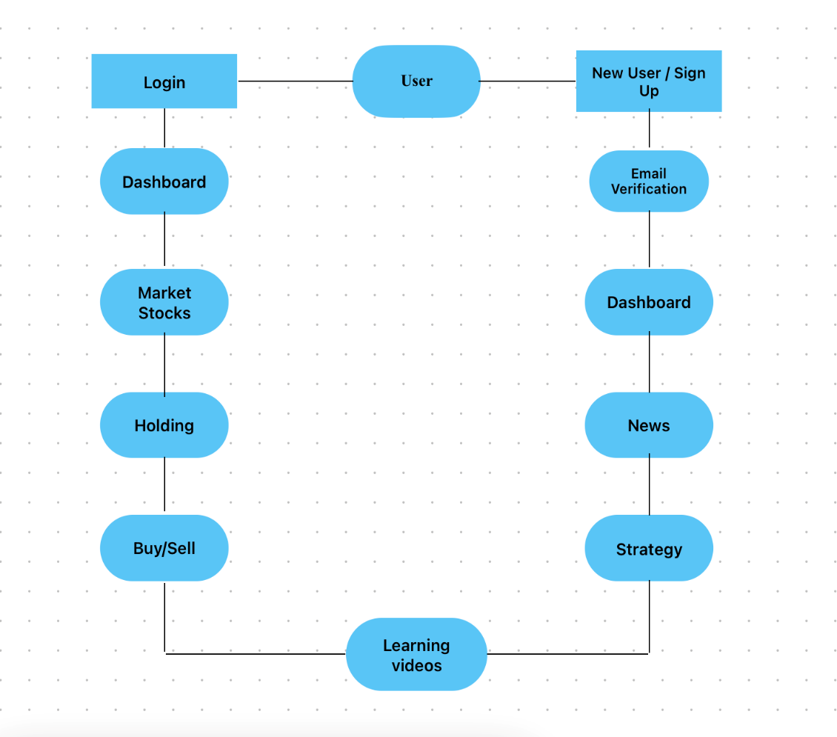systems, such as NASDAQ. These private systems may satisfy buy and sell requests among their own subscriber base or pass on the trade to the larger exchange.

Fig 3.2.1 Architecture of Stock Market

**3.2.2 LSTM**

LSTM stands for Long Short-Term Memory networks, which are a type of recurrent neural network (RNN) used in deep learning. Unlike standard feedforward neural networks, LSTM has feedback connections. LSTM networks use a series of gates that control how the information in a sequence of data comes into, is stored in, and leaves the network. The gates include an input gate, an output gate, and a forget gate. The cell remembers values over arbitrary time intervals, and the three gates regulate the flow of information into and out of the cell. The LSTM architecture aims to provide a short-term memory for RNN that can last thousands of timesteps, thus "long short-term memory

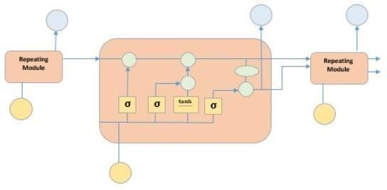

Fig3.2.2 LSTM Architecture

**3.2.3 Process of Stock Market Exchange**

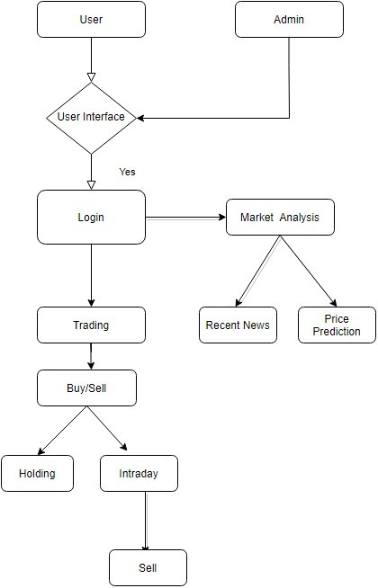The stock market is a trading platform where investors can buy and sell shares of publicly held companies. Companies raise capital by selling shares of stock, or equity, to investors. Stocks give shareholders voting rights and a share in the company's profits through dividends. Before a company can be listed on a stock exchange, it must meet certain conditions regarding company value and profitability.

Fig 3.2.3 Process of Stock Market Exchange

## SYSTEM REQUIREMENTS

In this section, all the necessary details are described so that it is made easier to design the product and validate it according to requirements. Here, it is important to describe all inputs the software handle and all the outputs to better define interaction with other systems and facilitate integration. So, have defined the hardware and software requirements required for successful working of this project.

## 3.3.1 Hardware Requirements

Hardware is the main part of this system. In this section, will describe the hardware requirements for construction and deploying the system, including the personal computer, having the internet services.

**Table** 3.3.1 Hardware Requirements

|  |  |
| --- | --- |
| Processor | Intel i3 (PC) |
| RAM | 4GB minimum |
| Disc Space | 25GB minimum |

## 3.3.2 Software Requirements

In this section will describe the software requirements for constructing and deploying the system.

**Table** 3.3.2 Software Requirements

|  |  |
| --- | --- |
| Operating System | Windows 8/9/10/11 |
| Programming Language | React |
| IDE | VS Code |

## CHAPTER 4

**TOOLS AND TECHNOLOGIES**

VS code

SQL workbench

SQL Plus

Node js

React Script

SQL Community

**4.1 Visual Studio Code**

Visual Studio Code, also commonly referred to as VS Code, is a source-code editor made by Microsoft with the Electron Framework, for Windows, Linux and macOS Features include support for debugging, syntax highlighting, intelligent code completion, snippets, code refactoring, and embedded Git.

Users can change the theme, keyboard shortcuts, preferences, and install extensions that add functionality .In the Stack Overflow 2022 Developer Survey, Visual Studio Code was ranked the most popular developer environment tool among 71,010 respondents, with 74.48% reporting that use it.

Visual Studio Code is a source-code editor that can be used with a variety of programmingLanguages,including C, C#, C++, Fortran, Go, Java, JavaScript, Node.js, Python, Rust.

It is based on the Electron framework, which is used to develop Node.js web applications that run on the Blink layout engine. Visual Studio Code employs the same editor component (codenamed "Monaco") used in Azure DevOps (formerly called Visual Studio Online and Visual Studio Team Services).

Some of the key features of VS Code include its highly customizable user interface, support for extensions and plugins that can enhance its functionality, integrated debugging and Git version control, and support for task automation and code snippets. It also provides various features such as live collaboration, IntelliSense code completion, and a built-in terminal, making it a versatile tool for developers across different platforms and workflows.Overall, VS Code is a popular choice among developers for its ease of use, versatility, and extensive features that make coding and development easier and more efficient.

**4.2 MySQL Workbench**

MySQL Workbench is a visual tool developed by Oracle, which helps to administer MySQL Databases. It is known for being a cross-platform software that allows MySQL to run on many platforms such as Windows, Linux, and macOS. MySQL Workbench is a unified cross-platform, open-source relational database design tool that adds functionality and ease to MySQL and SQL development work. You can create a Graphical Model using MySQL Workbench.

MySQL Workbench provides reverse engineering for live databases to models

MySQL Workbench offers a forward engineering model to a script/live database

MySQL Workbench possesses tools that allow database administrators to virtually create physical database design models that can be easily transitioned into MySQL databases using forward engineering.

MySQL Workbench adheres to all objects such as tables, views, stored procedures, triggers, etc.

MySQL Workbench also creates models from a target database or even imported SQL files.

MySQL Workbench comes with a visual SQL editor.

The Visual SQL editor gives developers the access to build, edit, and run queries against MySQL server databases. It has utilities for viewing data and exporting it.

MySQL Workbench has auto-complete and color highlighters that aid in the writing and debugging of SQL statements, easily.

Multiple queries can be run at a time, and the result is automatically displayed.

It also saves the queries in the history panel for previewing and running it later on.

**4.3 SQL Plus**

Graphical interfaces from Oracle or third parties have diminished the proportion of Oracle database end-users who depend on the SQL Plus environment. Oracle shops typically continue to use SQL Plus scripts for batch updating or simple reports.

Oracle Corporation's wrappers/gui-fications/replacements for SQL Plus include:

Oracle SQL Plus Worksheet, a component of OEM

iSQL Plus or iSQLPlus, a web-based utility

SQL Worksheet, a component of Oracle SQL Developer

SQL Workshop (part of Oracle Application Express

**4.4 Node.js**

Node.js (Node) is an open source, cross-platform runtime environment for executing JavaScript code. Node is used extensively for server-side programming, making it possible for developers to use JavaScript for client-side and server-side code without needing to learn an additional language. Node is sometimes referred to as a programming language or software development framework.

Node incorporates the V8 JavaScript engine, the same one used in Google Chrome and other browsers. It is written in C++ and can run on macOS, Linux, Windows and other systems. The engine parses and executes JavaScript code. It can operate independently of a browser environment, either embedded in a C++ application or implemented as a standalone program. The V8 engine compiles JavaScript internally, using just-in-time (JIT) processes to speed up execution.

A Node application runs in a single process. Node does not create a new thread for every request, as is often the case with traditional server-side programs. In this way, a Node server can handle thousands of concurrent connections without having to contend with thread concurrency issues or the overhead multithreading brings.

Node.js is event-driven and runs asynchronously. Code written for the Node environment does not follow the traditional model of receive, process, send, wait and receive found in other systems. Instead, Node implements an event loop that processes incoming requests as stack up in the event queue, handling small requests one after the other without waiting for responses.

**4.5 React script**

React is a JavaScript-based UI development library. Facebook and an open-source developer community run it. Although react is a library rather than a language, it is widely used in web development. The library first appeared in May 2013 and is now one of the most commonly used frontend libraries for web development. React offers various extensions for entire application architectural support, such as Flux and React Native, beyond mere UI.

Easy creation of dynamic applications: React makes it easier to create dynamic web applications because it requires less coding and offers more functionality, as opposed to JavaScript, where coding often gets complex very quickly.

Improved performance: React uses Virtual DOM, thereby creating web applications faster. Virtual DOM compares the components’ previous states and updates only the items in the Real DOM that were changed, instead of updating all of the components again, as conventional web applications do.

Reusable components: Components are the building blocks of any React application, and a single app usually consists of multiple components. These components have their logic and controls, and can be reused throughout the application, which in turn dramatically reduces the application’s development time.

Unidirectional data flow: React follows a unidirectional data flow. This means that when designing a React app, developers often nest child components within parent components. Since the data flows in a single direction, it becomes easier to debug errors and know where a problem occurs in an application at the moment in question.

**4.6 SQL Community**

MySQL Community Server is defined as an online platform that provides a quick and simple way of creating communities online. This community server contains all the integrated tools like blogs, discussion forums, file galleries, photo galleries, RSS tools, search, advanced user permissions, and content management essential for constructing communities.

MySQL Community Server also maintenances a number of gateways and add-ons which will enable further functionality consisting of posting to your blog using email, single sign-on modules, the capability to post as well as reply to forums using email, and also file administration tools to support easy drag and drop option for organizing the files or photo galleries.

The SQL community is diverse and global, with members from various backgrounds and levels of experience. It includes online forums, user groups, conferences, and other events where members can share knowledge, best practices, and new developments in the field. The community is known for its collaborative spirit and willingness to help each other out, with members often providing support, advice, and feedback to fellow SQL users.

The SQL community also plays an essential role in advancing the language and promoting its adoption in new industries and technologies. Members contribute to open-source projects, provide feedback to database vendors, and advocate for the use of SQL in data science and machine learning.

**CHAPTER 5**

**IMPLEMENTED WORK**

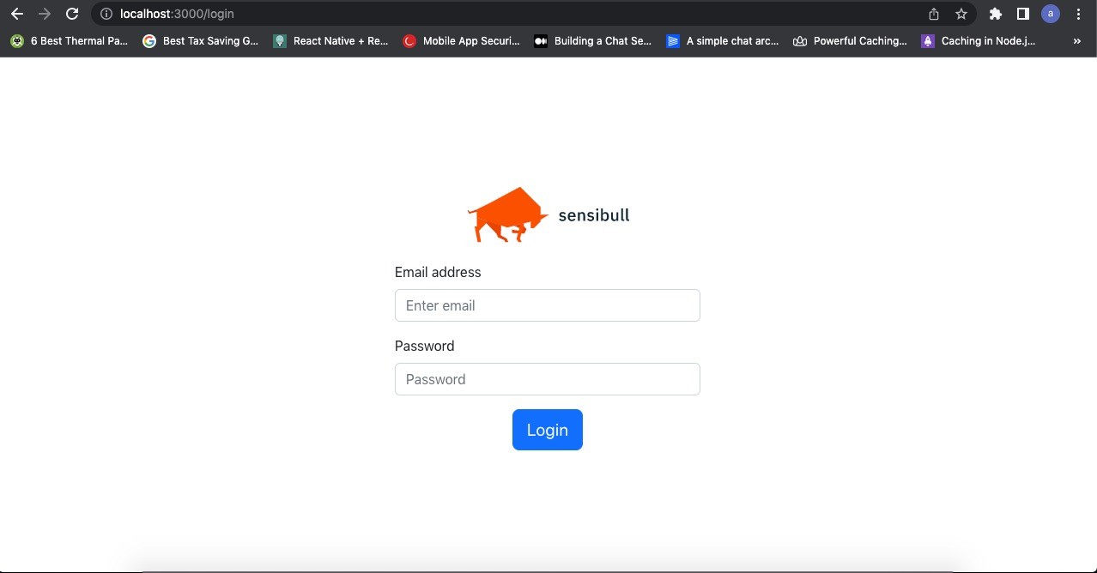

Fig 5.1 Login Page

It is the first page or login page of the web application which has a array to access a web application by entering their username ,password by authenticating with a social network of stock market then click on login.

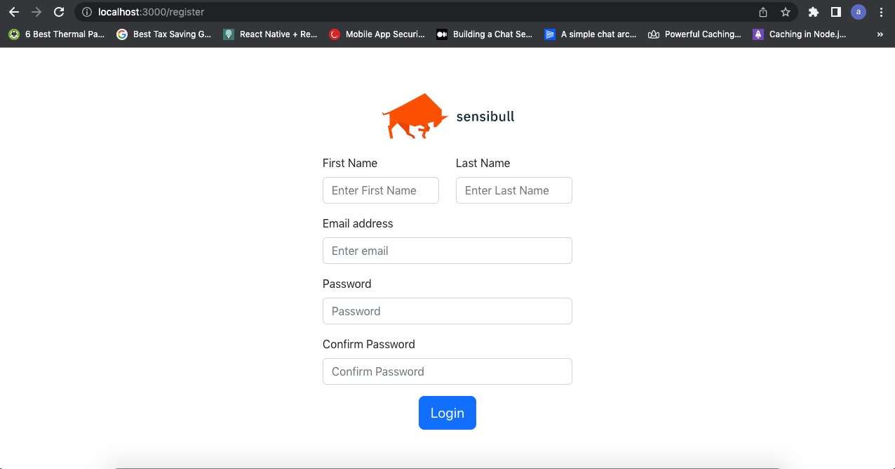

Fig 5.2 Sign up Page

Sign-up page that enables to click on First name, last name, email ,address, password, confirm password then will open and it look to above picture to get login.

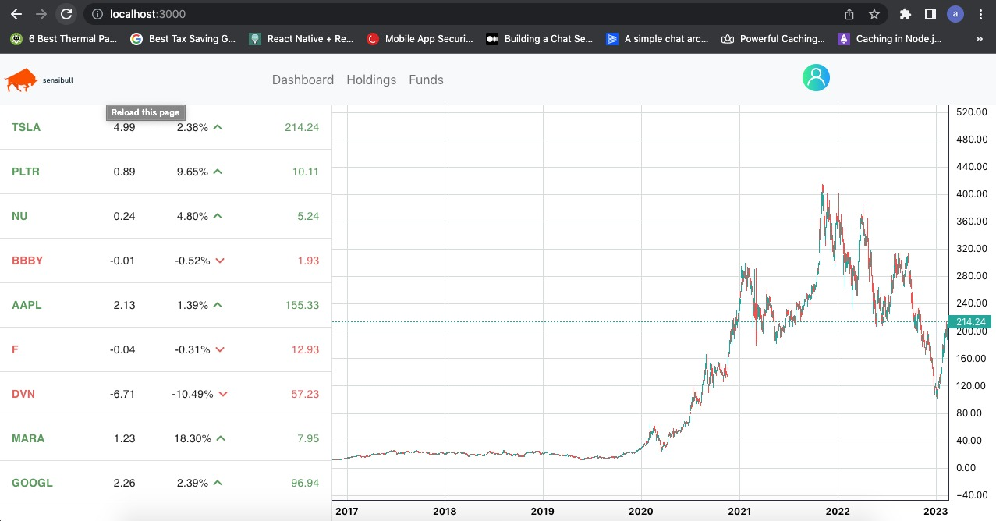

Fig 5.3 Dashboard Page

Dashboard representing the up and down of the specific listed stock company.

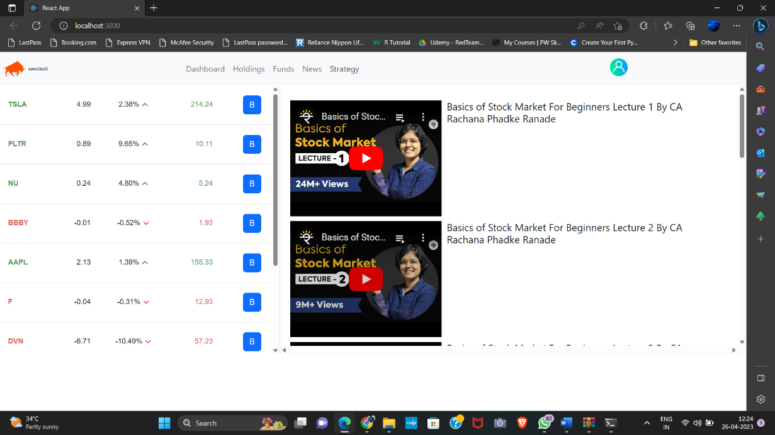

Fig 5.4 Learning and Strategy Page

Represent that how to trade how to see the pattern and make the prediction of pattern.

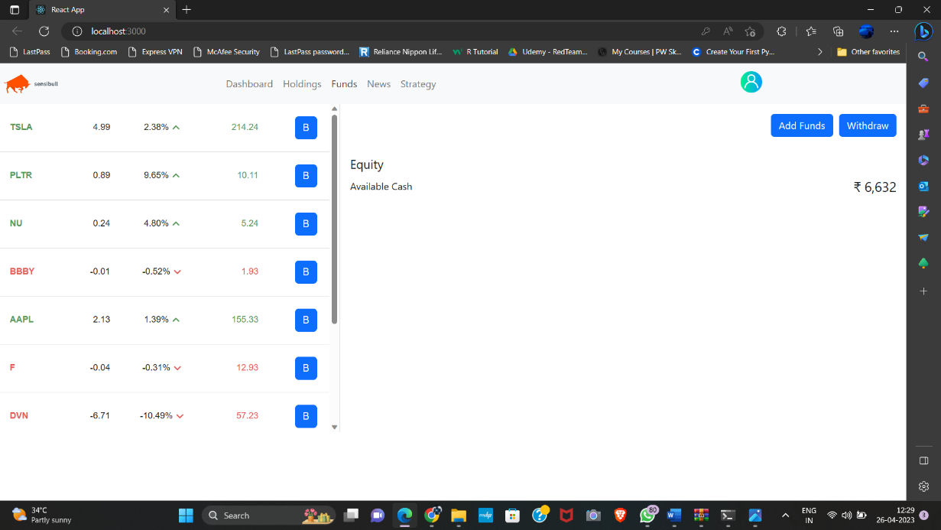

Fig 5.5 Funds Page

Funds page represent the addition of amount and withdrawal of amount

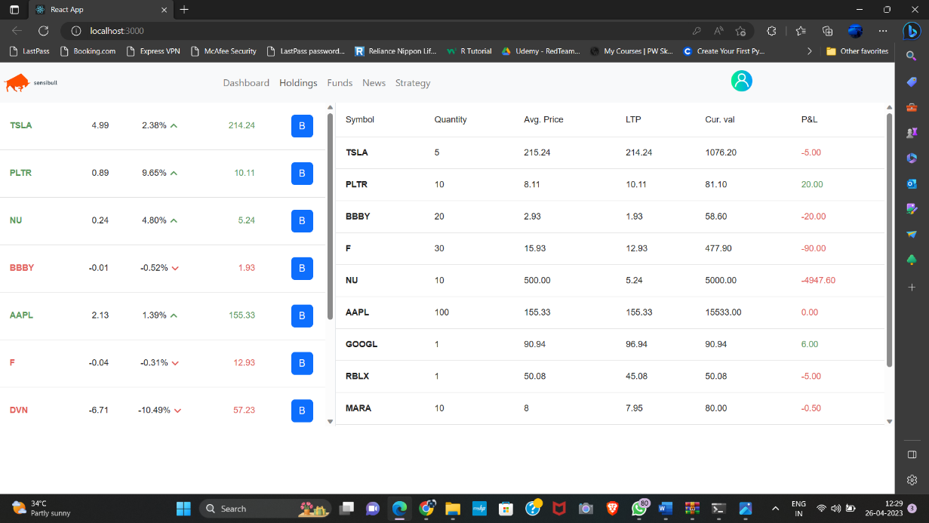

Fig 5.6 Holdings Page

Holding page represent the stock that buy and take on our holding shares

**IEX Cloud**

IEX Cloud will release new versions of the API when make backwards-incompatible changes. Plan to support up to three active versions and will give advanced notice before releasing a new version or retiring an old version.

Backwards compatible changes:

Adding new response attributes

Adding new endpoints

Adding new methods to an existing endpoint

Adding new query string parameters

Adding new path parameters

Adding new web hook events

Adding new streaming endpoints

Changing the order of existing response attributes

Both the IEX Cloud platform and the financial data ecosystem are constantly evolving, so it may become necessary to deprecate or disable some endpoints without versioning the entire API. Some situations which might require this action include changes to data contracts, critical useability issues, data universe expansion, etc. In these situations we will make every effort to provide alternative access to the underlying data or another provider’s data, and maintain the deprecated endpoints for a reasonable timeframe.

An endpoint will be removed ~6 Months from the time of deprecation with advance notice given via email and any alternative functionality available in both the API and official client libraries.

## CHAPTER 6

## RESULTS AND DISCUSSIONS

As a language model, do not have access to real-time data on the stock market, so cannot provide specific results or discussions on the current state of the stock market.

However, in general, the stock market can be analyzed based on various performance indicators, such as market indices, stock prices, trading volume, and market capitalization. These indicators can provide insight into the overall health and direction of the stock market.

Additionally, the stock market can be analyzed from different perspectives, such as the macroeconomic factors that influence it (e.g. interest rates, inflation, GDP growth), the performance of individual companies or sectors, and global events that may impact investor sentiment.

When discussing the stock market, it is also important to consider different investment strategies, such as active vs. passive investing, diversification, and risk management. These strategies can affect the potential returns and risks associated with investing in the stock market.

The stock market is a complex and dynamic system that requires careful analysis and consideration before making investment decisions. It is important to seek out reliable information and advice, and to have a clear understanding of one's investment goals and risk tolerance.

Learning stock market application is a complex and challenging task that requires a good understanding of financial concepts and market dynamics. It involves analyzing data, developing investment strategies, and making informed decisions based on market trends and economic indicators.

One approach to learning stock market application is through formal education and training programs, such as finance or economics degrees, which provide students with a solid foundation in financial theory and analysis. These programs may also offer specialized courses in stock market analysis and portfolio management.

Another approach is to learn through practical experience, such as investing in the stock market and observing market trends. This approach can be risky, as it involves using real money and may result in financial losses if not done carefully. However, it can also provide valuable insights into the workings of the market and the behavior of different types of investments.

In recent years, there has been an increase in the use of technology and artificial intelligence (AI) in stock market analysis and trading. AI-based tools and platforms can help investors make more informed decisions by analyzing vast amounts of market data and identifying patterns and trends that may not be easily visible to human analysts. These tools can also be used to develop automated trading strategies that can execute trades based on pre-defined rules and criteria.

One of the essential steps in learning about the stock market exchange is to familiarize yourself with the different types of financial instruments available, such as stocks, bonds, mutual funds, and exchange-traded funds (ETFs). Should also learn how to analyze company financial statements and economic indicators to identify investment opportunities and assess risks.

It's also important to have a solid understanding of investment strategies, such as value investing, growth investing, and momentum investing, and how to implement them effectively. Developing a disciplined approach to investing, setting realistic financial goals, and diversifying your portfolio are other important considerations.

Additionally, staying up to date with market news, trends, and analysis is crucial in making informed investment decisions. There are various resources available to help you stay informed, including financial news websites, stock market blogs, and social media platforms.

Finally, learning about the stock market exchange is an ongoing process. It requires continuous education, self-reflection, and learning from past mistakes. As gain experience, can refine investment strategies and make more informed decisions.

In conclusion, learning about the stock market exchange is a challenging but rewarding process. By developing a solid understanding of financial and economic concepts, investment strategies, and market trends, can make informed investment decisions and achieve financial goals.

CHAPTER 7

**CONCLUSION**

The stock market is a complex system that allows companies to raise capital by issuing shares to the public, and investors to buy and sell those shares in the hopes of making a profit. The stock market is influenced by a variety of factors, including economic indicators, company performance, political events, and global events.

Investing in the stock market can be risky, as there is no guarantee of returns and the value of stocks can fluctuate significantly over time. However, with proper research and risk management strategies, investing in the stock market can also be a profitable way to grow wealth over the long term.

It is important to remember that the stock market should not be viewed as a get-rich-quick scheme, and that investors should have a long-term investment strategy in place that is aligned with their financial goals and risk tolerance.

Overall, the stock market can provide opportunities for both companies and investors, but it is important to approach it with caution, diligence, and a long-term mindset.

## 7.1 Limitations of Study

## As an AI language model, I don't have the capability to create a web application on my own, but I can provide you with some guidance on what features and functionalities you might want to include in a web application focused on learning stock market exchange:

## users with the tools and resources need to learn and succeed in the stock market. Educational resources: Provide a range of educational resources to help users learn about the stock market, such as tutorials, articles, videos, and interactive quizzes.

## Real-time stock market data: Display real-time stock market data, including stock prices, market indices, and financial news.

## Virtual trading: Offer users the opportunity to practice trading without risking real money by providing a virtual trading platform.

## Portfolio management: Allow users to create and manage their stock portfolio, including tracking their investments and performance.

## Social interaction: Create a social platform for users to interact with each other, ask questions, and share insights and strategies.

## Alerts and notifications: Send users alerts and notifications regarding changes in the market, their portfolio performance, and other relevant news and information.

## Customization: Allow users to customize the web application according to their preferences, such as language, theme, and layout.

## User-friendly interface: Design a user-friendly interface that is easy to navigate and use, especially for beginners.

## Customer support: Provide customer support through multiple channels, such as email, chat, and phone, to help users with any issues may encounter.

## Overall, a successful web application on learning stock market exchange should be educational, informative, interactive, and user-friendly, providing

## 7.2 Future Scope

The future scope of stock market exchange is quite promising. With the advancements in technology and the increasing adoption of digital platforms, the stock market exchange is expected to become more efficient, transparent, and accessible.

Some of the potential areas of growth in the stock market exchange include:

Increased use of AI and Machine Learning: The use of AI and machine learning algorithms can help investors make better decisions by analyzing large amounts of data and predicting market trends.

Integration of Blockchain Technology: The integration of blockchain technology can increase the transparency and security of transactions in the stock market exchange.

Expansion of Global Markets: The stock market exchange is expected to expand globally, allowing investors to trade in markets beyond their geographical boundaries.

Rise of Sustainable and Socially Responsible Investing: The rise of sustainable and socially responsible investing is expected to drive growth in the stock market exchange as investors seek to invest in companies that align with their values and beliefs.

Increase in Retail Investor Participation: The rise of digital platforms and the availability of low-cost investment options are expected to increase the participation of retail investors in the stock market exchange.

Overall, the future of the stock market exchange looks promising as it continues to evolve and adapt to changing market conditions and technological advancements.

# References

# Gunu, U. & Idris, I. (2009). “Environmental Factors Influencing Fluctuation of Share Prices on Nigeria Stock Exchange Market *.”* An International Multi- Disciplinary Journal, Ethiopia 3(5), 199-212.

# AL, FN. & Shubiri. (2010). “Analysis the Determinants of Market Stock Price Movements: An Empirical Study of Jordanian Commercial Banks.” International Journal of Business and Management, 5(10), 137-147.

# Girard, EC.(2010). “Empirical Evidence of the Existence of Investable Premiums in Emerging Market Investable Stocks.” The Financial Review, 45, 1025–1051.

# Shen, CH. & Lin, KL. (2010). “The Impact of Corporate Governance on the Relationship Between Fundamental Information Analysis and Stock.” Returns.Emerging Markets Finance & Trade, 46(5),90-105.

# Butt, BZ. Rehman, KU. Khan, MA. & Safwan, N.(2010). “Do Economic Factors Influence Stock Returns? A Firm and Industry Level Analysis.” African Journal of Business Management, 4(5), 583–593.

# Sharma, Dr S. (2011). “Determinants Of Equity Share Prices In India.” International Refereed Research Journal, 2(4), 51-60.